Project A Reflection

Jawal Trivedi Group 14

In terms of time management, I think our group could have improved on that front. We started off relatively quickly in the first two weeks and as workload started piling up, we kept on pushing the project back. This took a chunk of our assembly time which could’ve been used to address some design flaws. Even if we worked on it for 4-5 hours per week, we would have managed to finish everything before time. In the future, I intend using tools such as the Gantt Chart which helps the group stay on track and finish without having to rush anything.

The tasks were split fairly amongst the pair, this way it ensured that both of us got to have experience on main learning objectives of the project. For example, both of us worked on the dynamic simulations, both of us got to 3D Print, both of us helped in post-processing as well as assembly.

We iterated a lot during the prototyping phase. Some of these were foreseeable and some not. For example, e.g. we printed the holes for the 3mm shaft to exact dimensions, which lead to a lot of filing. In terms of iteration we also made a lot of changes whilst designing on Inventor, for example, once the supports were added, we noticed that they were intruding the ramp’s space, therefore we needed to go back and change its design. Both design flaws mentioned were foreseeable, however we acted on one by purposely printing the exact dimensions and didn’t act on the other by changing our design to account for space. An unforeseeable iteration was the design of our gears. Because of an error in calculation, we unknowingly printed gears with incorrect dimensions, thus we had to iterate back, change our design to suit the new calculations and reprint.

A design decision that we regret is not having the holes of the gears dimensioned to account for tolerances, we spent a lot of time post-processing because of it, therefore prototyping phase would’ve been quicker if we had decided otherwise. Also, since our second print we were experienced enough to add in the supports ourselves, however we decided to select ‘Everywhere’ on the next prints because we weren’t confident enough. We could’ve reduced our print times by doing this.

There are a few changes we would make to our design, so its more precise and robust. The first one is using correct tolerances for parts that need to be inserted, for example the gears and cam. Similarly, we would also chamfer the edges, so insertion is smooth. By practising these two things, we would minimise the post processing time which was used on unnecessary filing. We would change our design in a way which utilises less glue. We found out during assembly that using glue becomes very messy very quick. An alternative option we discussed is making use of the fasteners that were provided, for parts such as the ramp and supports. In our design we created a coupling which connects the first gear and the rotational input as shown in Figure 1, however we could’ve combined the coupling and first gear so that its one part instead of two. We also found that the first gear in the final assembly was quite unstable and thus having extra supports which fixates the shaft could’ve been useful. Another aspect where we could’ve developed on was the supports itself. Rather than having semi-circular grooves for the shaft to rest in (refer to Figure 2), have holes extruded large enough for the shaft to spin. This would prevent the shaft from falling out of place.

In terms of the design process, our group followed the proper procedure and used numerous design tools to make certain decisions, for example, we created a PDS, utilised the Product Decomposition to break down the design problem, implemented the Pugh’s Matrix to narrow down to our decisions etc. However, in the future I would also make use of the Gantt Chart to keep track of time and where we should be in the project.

Overall, we managed to produce a design fitting the requirements on paper, although, it didn’t work during the demonstration. We know that if we managed our time better, a fully functioning design would be the outcome. We have learnt a lot from this project and are looking forward to implementing some of our learnt lessons in future projects.

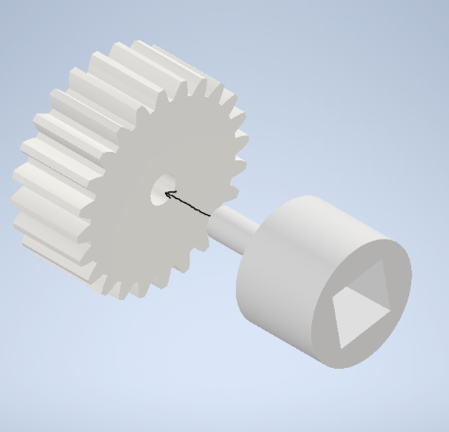

Figure

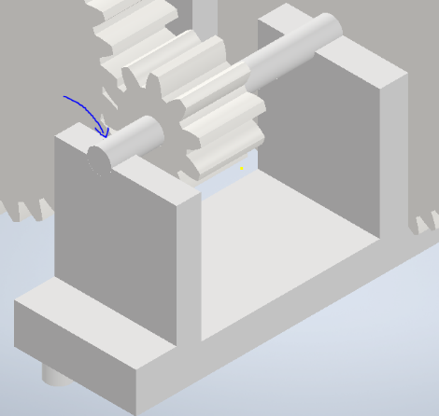

Figure